Task 1 - High-Level Architecture
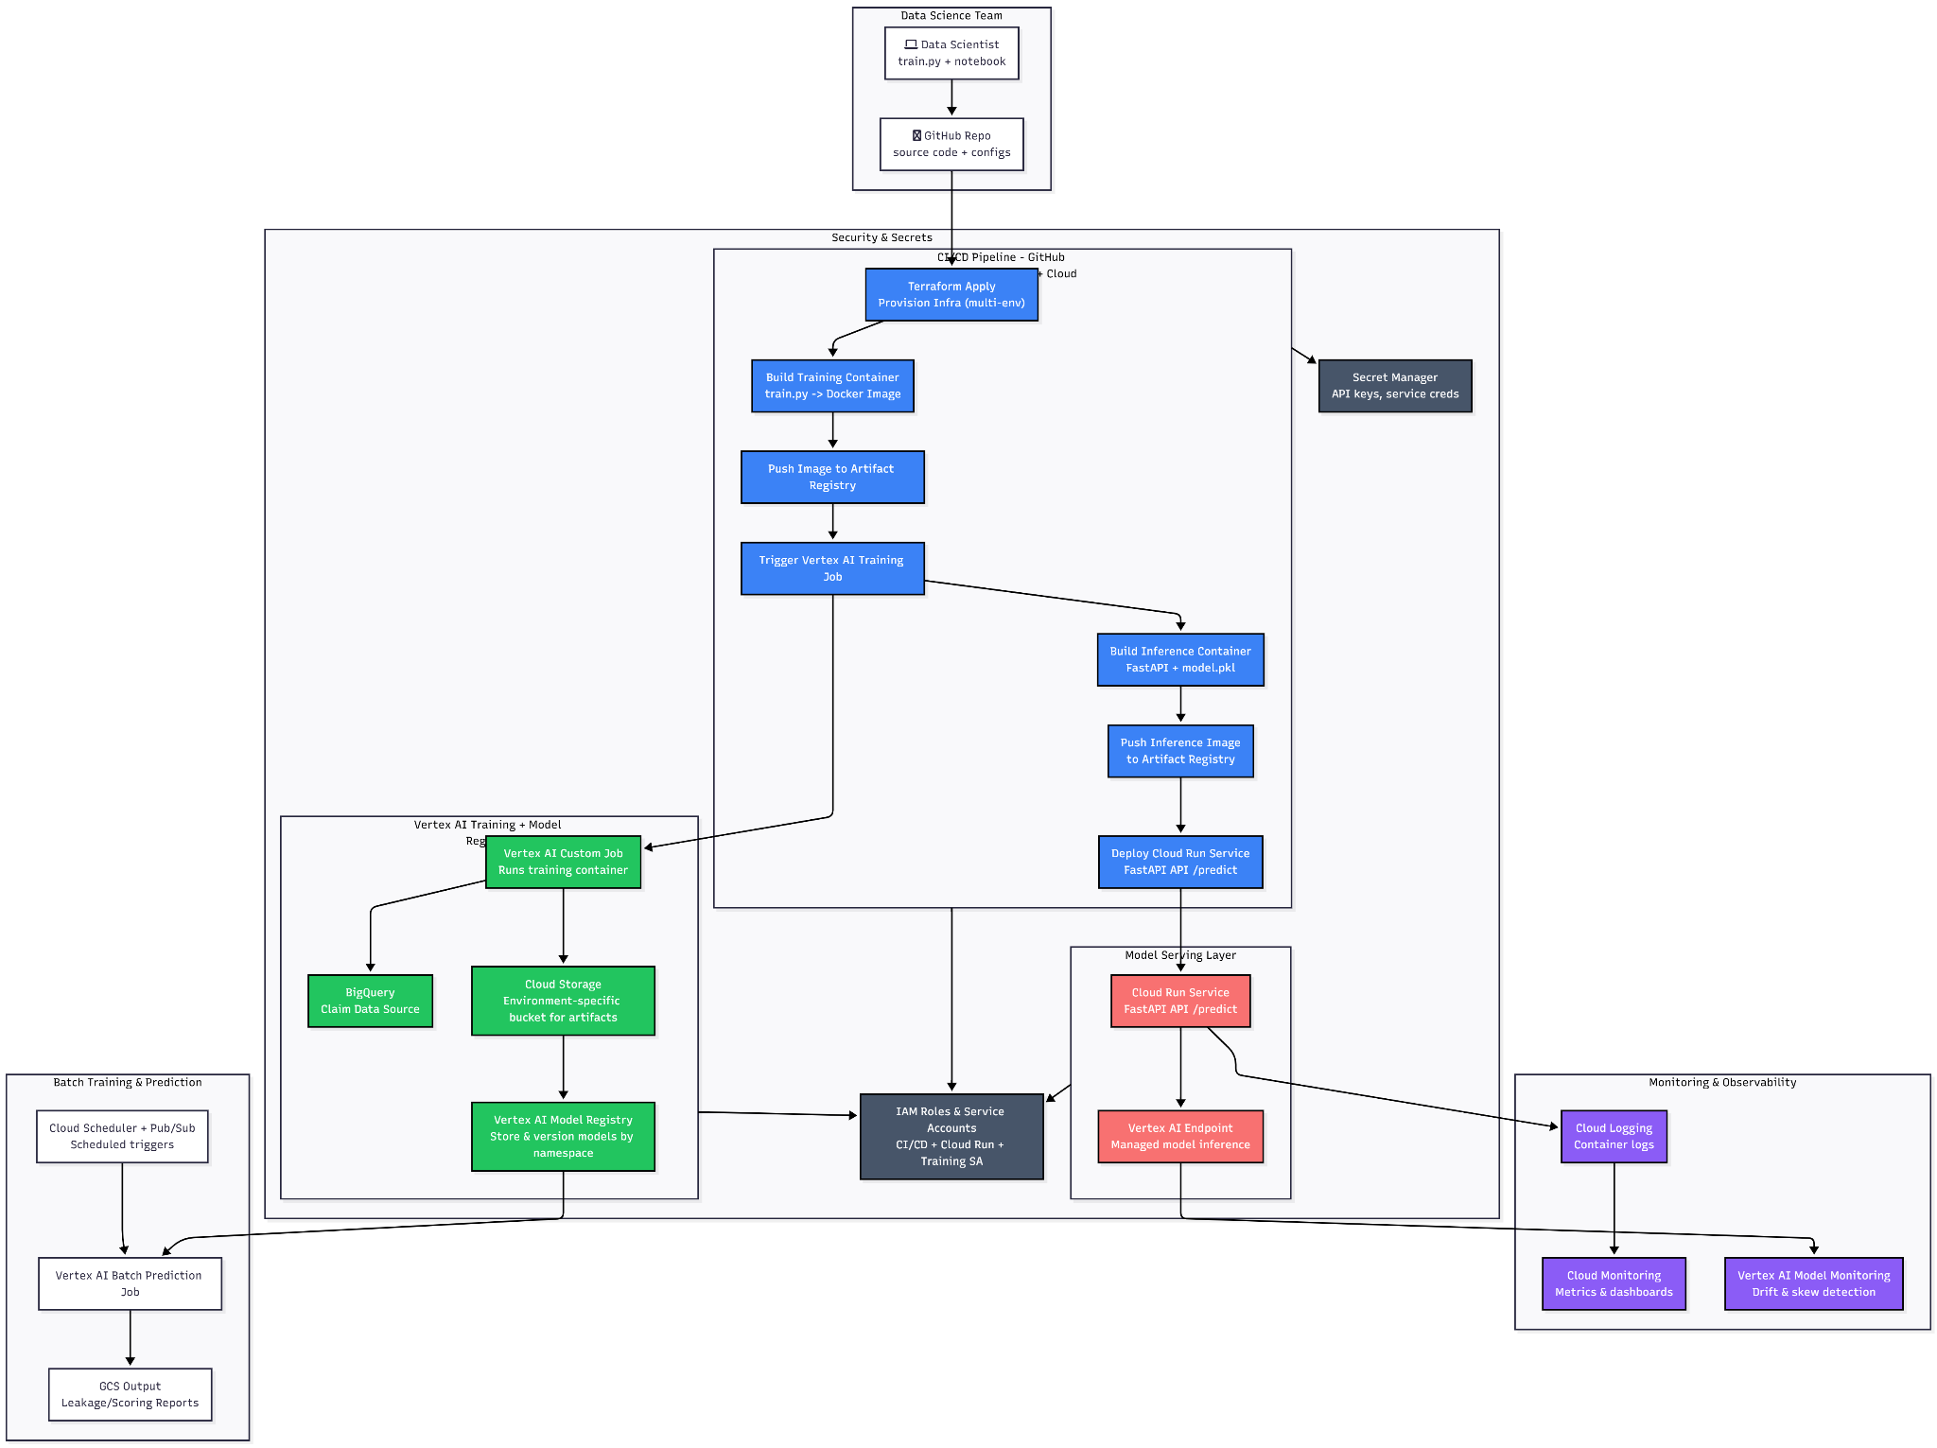

A Brief Overview of the Architecture
The MLOps system automates the process of training, deploying, and serving machine learning models at scale. The workflow begins with research artifacts provided by the data science team (e.g., Jupyter notebooks) which are converted into reusable Python modules for training and data preprocessing. These modules pull data from BigQuery, train models, and export the trained artifacts to the Vertex AI Model Registry.
The entire process is integrated into a CI/CD pipeline that ensures reproducibility, environment isolation, and safe deployment across multiple production environments.

Workflow Summary
- CI Pipeline Trigger
  - A Pull Request (PR) or merge to the main branch triggers the CI pipeline.
  - The CI pipeline provisions infrastructure on GCP through Terraform, builds Docker images for both training and inference services, and pushes these images to Google Artifact Registry.
- CD Pipeline Execution
  - Vertex AI Training Jobs are executed using the training Docker images stored in Artifact Registry.
  - Trained models (model.pkl files) are stored in Vertex AI Model Registry, with versioning, metadata, and training metrics automatically logged.
  - Post-training, the inference service is deployed to Cloud Run, pulling prediction images from Artifact Registry and exposing FastAPI endpoints that comply with the API contract.
- Batch Training Jobs
  - Periodic or scheduled training runs are triggered using Cloud Scheduler and Pub/Sub, allowing batched retraining of models using updated datasets.

2. System Components
Component | Purpose
Artifact Registry | Stores Docker images for training jobs and the inference service.
Cloud Run | Serves prediction endpoints via FastAPI ASGI server for inference.
BigQuery | Centralized data source for training and batch predictions.
Vertex AI Model Registry | Stores trained models (model.pkl) with versioning, metadata, and metrics.
Pub/Sub Broker | Orchestrates scheduled batch training jobs and retraining triggers.
Cloud Scheduler | Triggers batch training pipelines at defined intervals.
Feature Store | Central repository for preprocessed features (optional).

3. Repository Strategy
A mono-repo strategy is used to maintain reusability and reduce complexity:
repo-root/
├─ infrastructure/ # Terraform + Docker configs
├─ ci-cd/ # CI/CD pipeline definitions
├─ ml_training/ # Python modules for data preprocessing and training
├─ model_serving/ # FastAPI inference service
└─ tests/ # Unit & integration tests

Rationale:
- Keeps components tightly coupled and versioned together.
- Simplifies dependency management and ensures reproducibility.

4. CI/CD Pipeline

Continuous Integration (CI)
- Infrastructure Provisioning
  - Terraform provisions GCP resources idempotently across environments.
  - Includes BigQuery datasets, Cloud Run services, Artifact Registry, Secret Manager secrets, and Pub/Sub topics.
- Docker Image Build
  - Training and inference images are built and pushed to Artifact Registry.
- Automated Testing
  - Unit and integration tests for ML modules and API endpoints are executed.

Continuous Deployment (CD)
- Vertex AI Training Jobs
  - Training images are pulled from Artifact Registry.
  - Trained models are registered in Vertex AI Model Registry with metadata and versioning.
  - Metrics are collected and logged (e.g., accuracy, latency).
- Inference Deployment
  - Prediction images are deployed to Cloud Run.
  - FastAPI endpoints expose model predictions.
- Batch Retraining
  - Cloud Scheduler triggers batch training jobs.
  - Pub/Sub messages orchestrate scheduled job execution.

5. Multi-Environment Management
The system supports three production environments:
Environment | Project Name | Purpose
Dev | ManyPets-ml-dev | Experimentation, feature validation
Staging | ManyPets-ml-staging | Pre-production testing, QA
Production | ManyPets-ml-prod | Live inference and model serving

Environment Isolation
- Separate GCP projects for each environment.
- Parameterized Terraform with .tfvars per environment ensures reproducibility and isolation.
- Different IAM roles and permissions per environment.

Model Namespacing
- Models are organized in Vertex AI Model Registry by namespace:
  - Claims_outlier_model
  - Fraud_detection_model
- Each environment maintains separate versions of models, artifacts, and training metadata.

Buckets and Storage
- Each environment has dedicated storage buckets for:
  - Training datasets
  - Model artifacts
  - Logs and metrics
Example:
gs://manypets-ml-dev-models/
gs://manypets-ml-staging-models/
gs://manypets-ml-prod-models/

6. Release Management & Rollbacks
- Staging Deployments
  - Merge to main automatically deploys to staging.
  - Manual approval is required to promote to production.
- Canary Deployments
  - Deployments in Cloud Run use traffic splitting (e.g., 10% new, 90% old).
  - Gradual rollout mitigates risks of production failures.
- Rollback Strategy
  - Maintain last 2 container images in Artifact Registry for instant revert.
  - Cloud Run traffic can be redirected to previous revisions in seconds.

7. Monitoring and Observability
- SLOs
  - Latency (99th percentile)
  - Error rate (5xx)
  - Request count
  - Model drift proxy metrics
- Alerting
  - Cloud Monitoring policies track SLO violations.
  - Alerts notify the team if thresholds are exceeded (latency spikes, model drift, high error rates).

8. Summary
The system is designed for reproducible, scalable, and safe ML operations:
- CI/CD ensures automated testing, training, and deployment.
- Multi-environment isolation enables safe experimentation and promotion to production.
- Secret management, canary releases, and rollback strategies reduce operational risks.
- Monitoring and alerting provide observability and reliability.
- Cloud Scheduler orchestrates recurring batch training jobs.

